**East West University**

**Lab Report 1**

**Course code: CSE 325**

**Course title: Operating System**

**Semester: Spring22**

**Section: 01**

**Submitted By**

**Md. Redwan Ahmed**

**Id: 2019-1-60-249**

**Submitted To**

**Dr. Md. Nawab Yousuf Ali**

**Professor  
Department of Computer Science & Engineering**

**Submission Date**

**3rd March 2022**

Task 1:

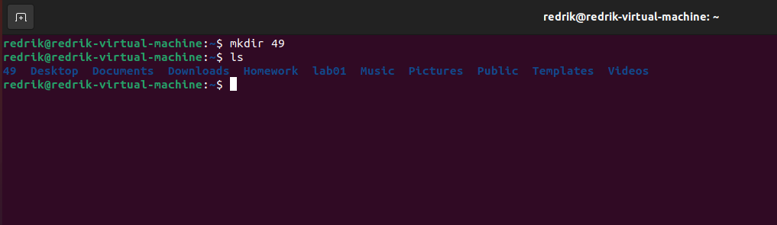

Task 2:

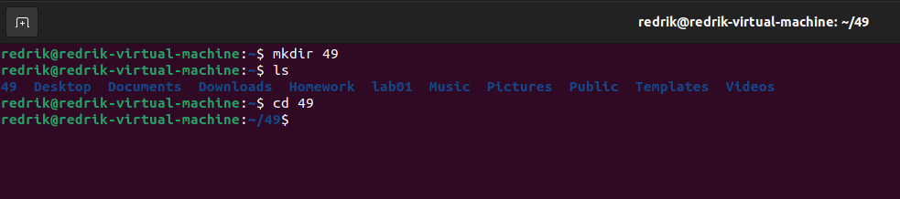

Task 3:

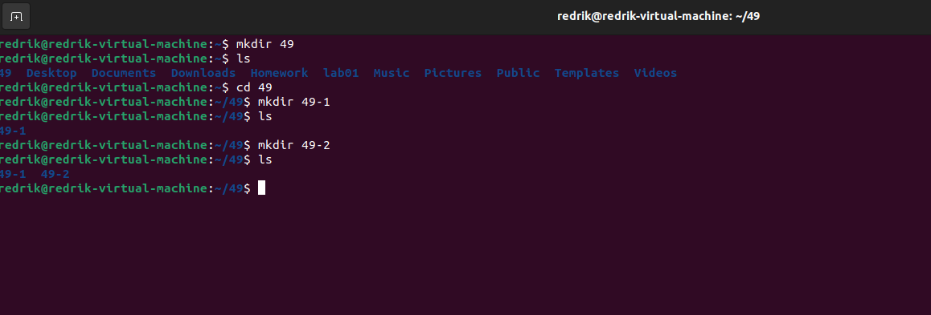

Task 4:

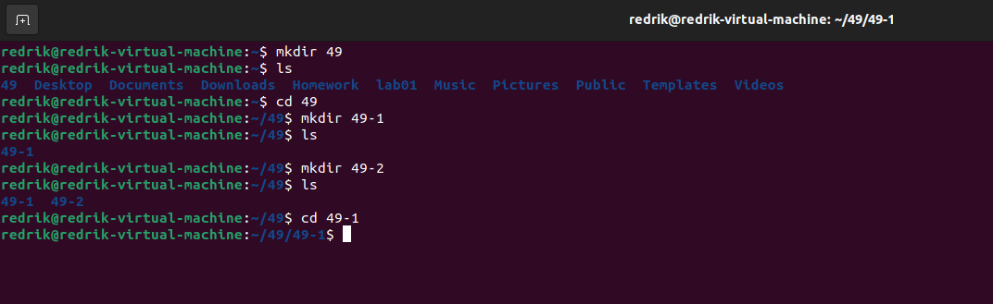

Task 5: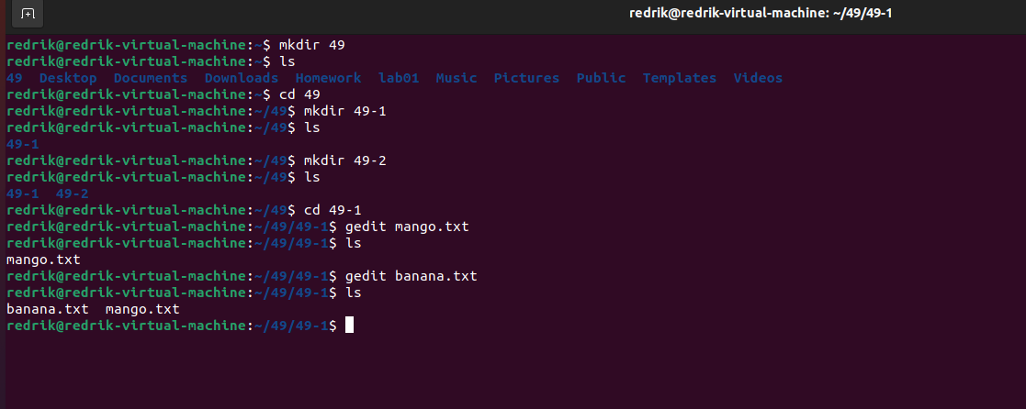

Task 6:

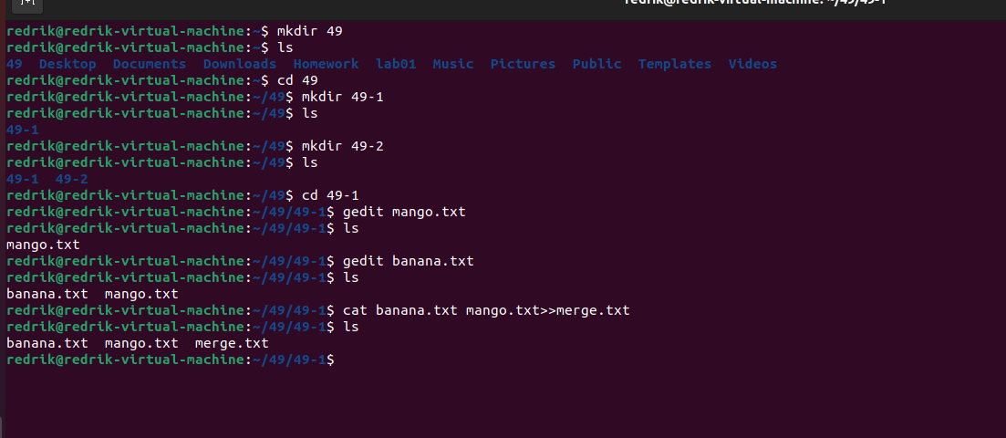

Task 7:

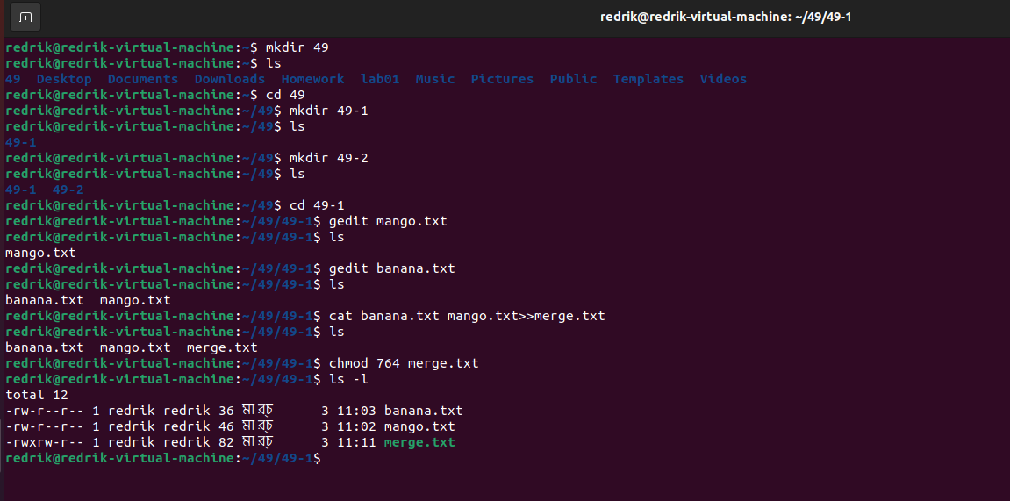

Task 8: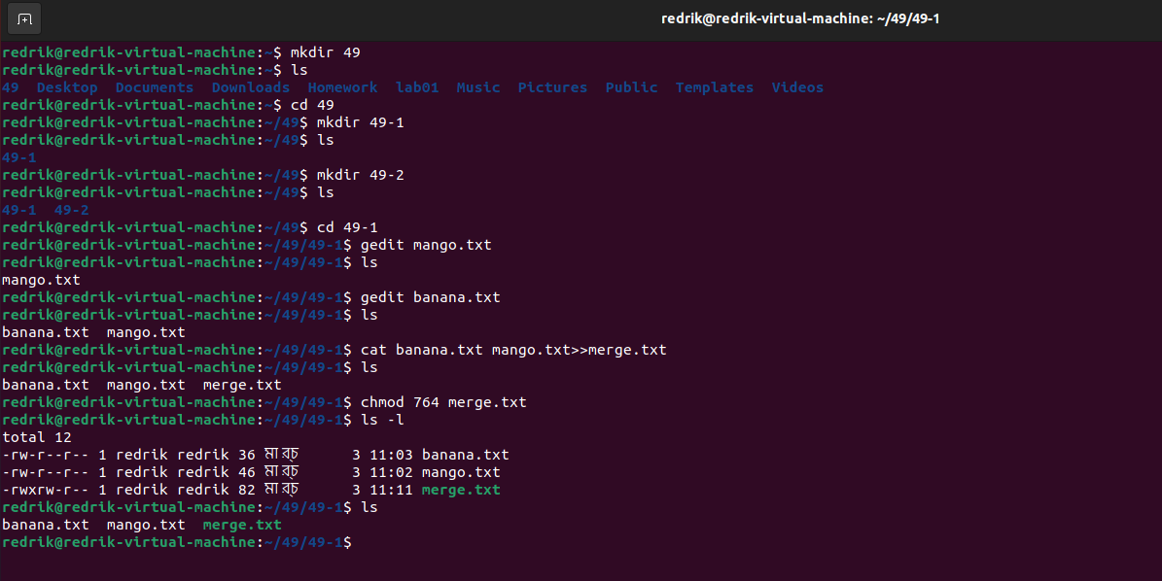

Task 9:

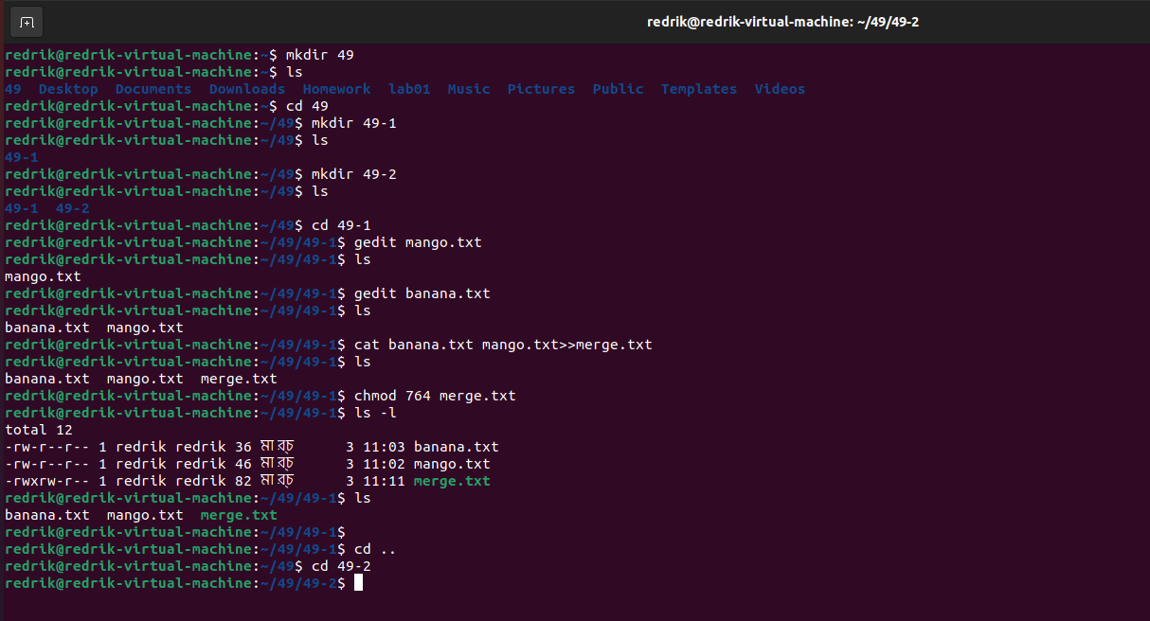

Task 10: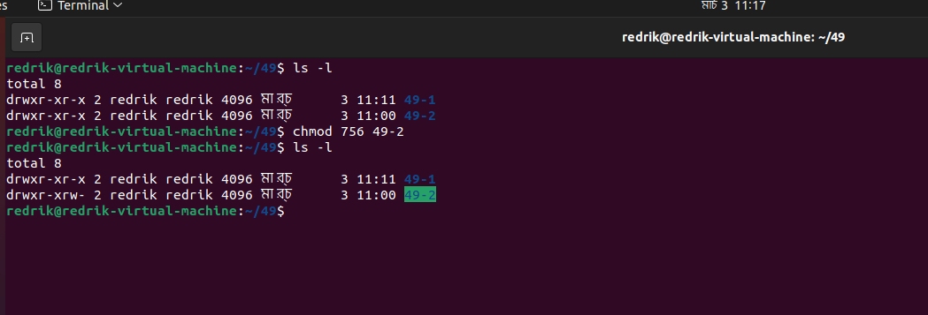

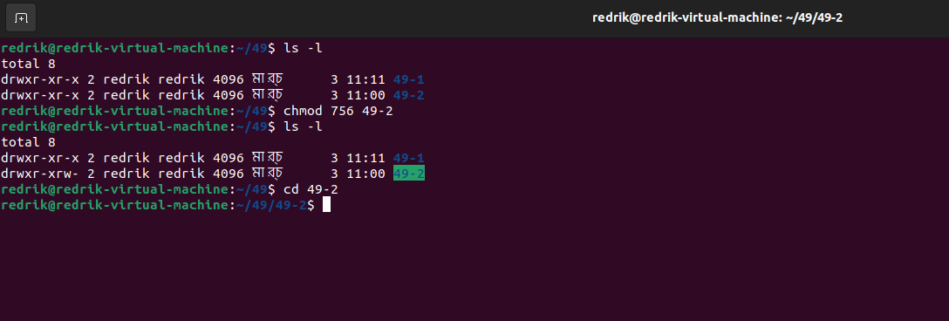

Task 11:

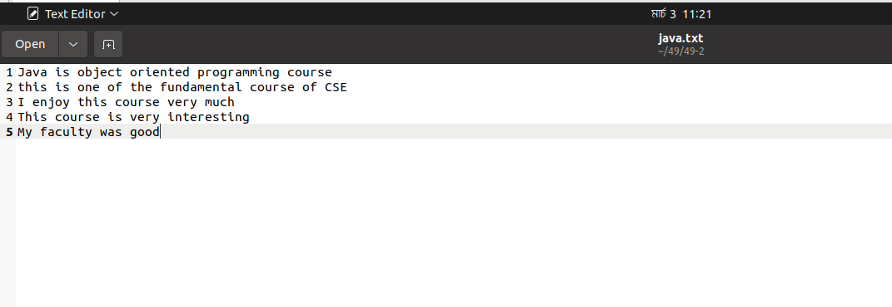

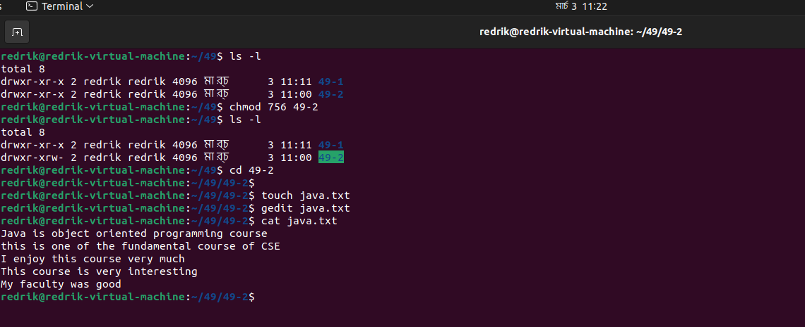

Task 12: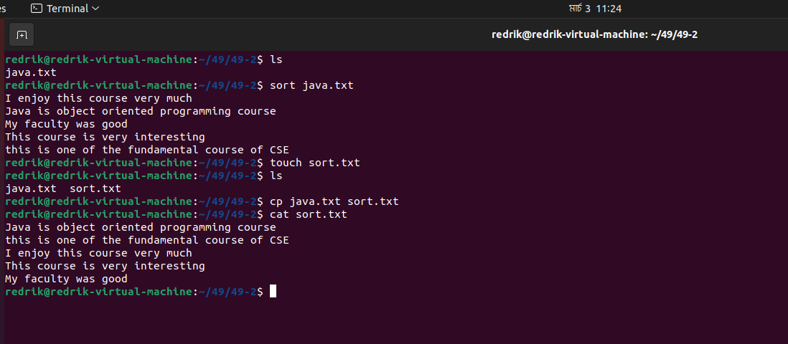

Task 13:

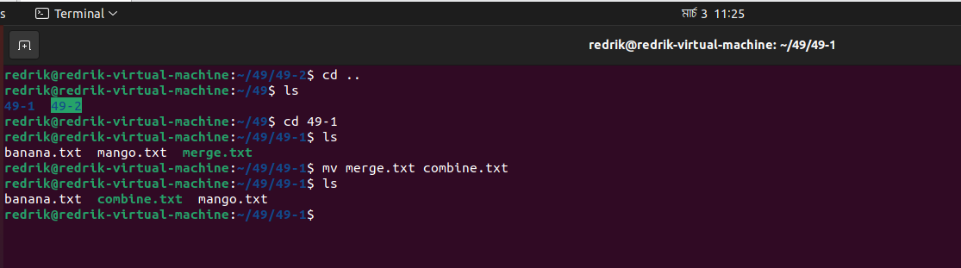

Task 14:

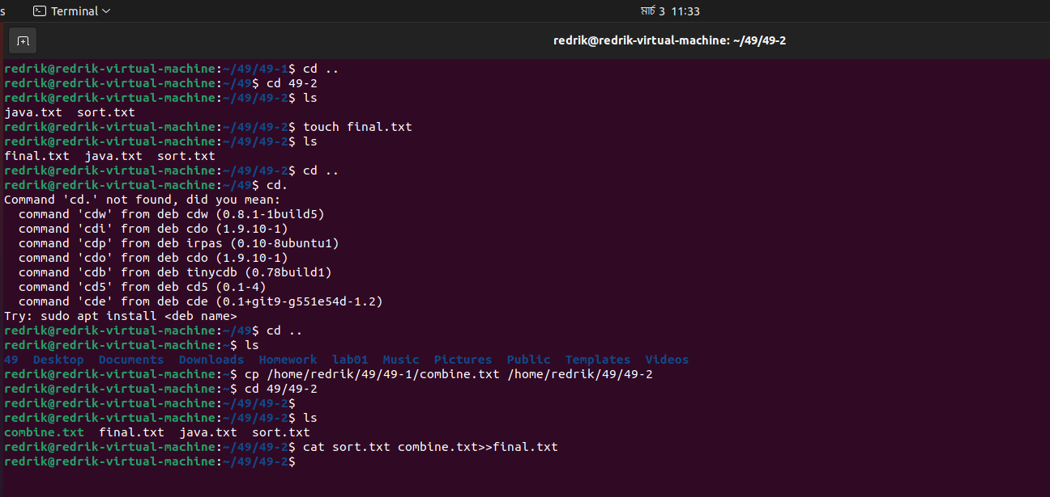

Task 15: 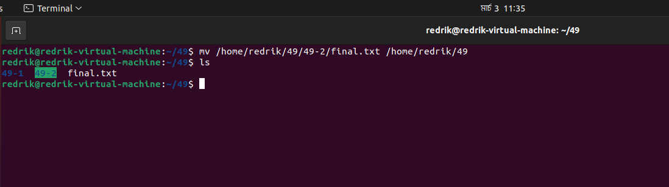

Task 16:

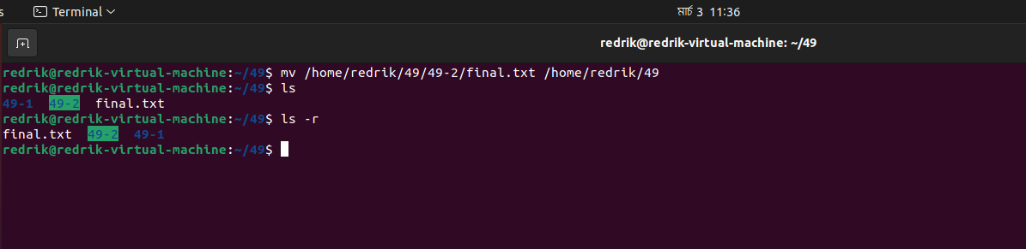

Task 17:

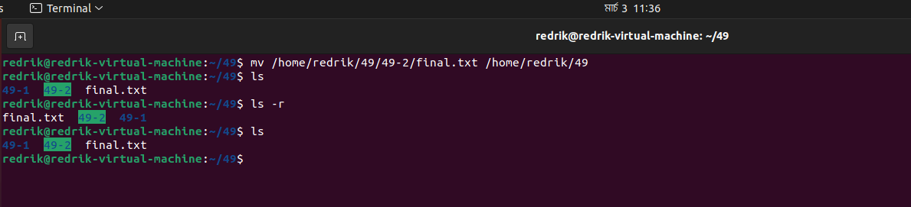

Task 18:

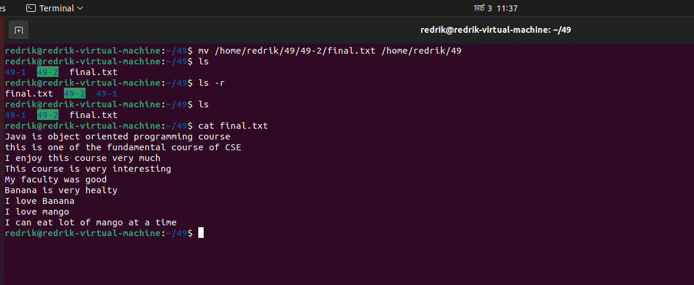

**The End**